**Ideation Phase**

**Define the Problem Statements**

|  |  |
| --- | --- |
| Date | 31 January 2025 |
| Team ID | LTVIP2025TMID59800 |
| Project Name | Smart Sorting: Transfer Learning for Identifying Rotten Fruits and Vegetables |
| Maximum Marks | 2 Marks |

**Customer Problem Statement Template:**

Post-harvest losses due to spoiled produce affect both retailers and consumers. Traditional visual sorting techniques fail to keep up with high volumes and often miss early signs of rot. This project uses transfer learning to build an image-based classification system that distinguishes fresh fruits and vegetables from rotten ones. This automation helps ensure food quality, reduce wastage, and boost consumer trust.

Reference: <https://miro.com/templates/customer-problem-statement/>

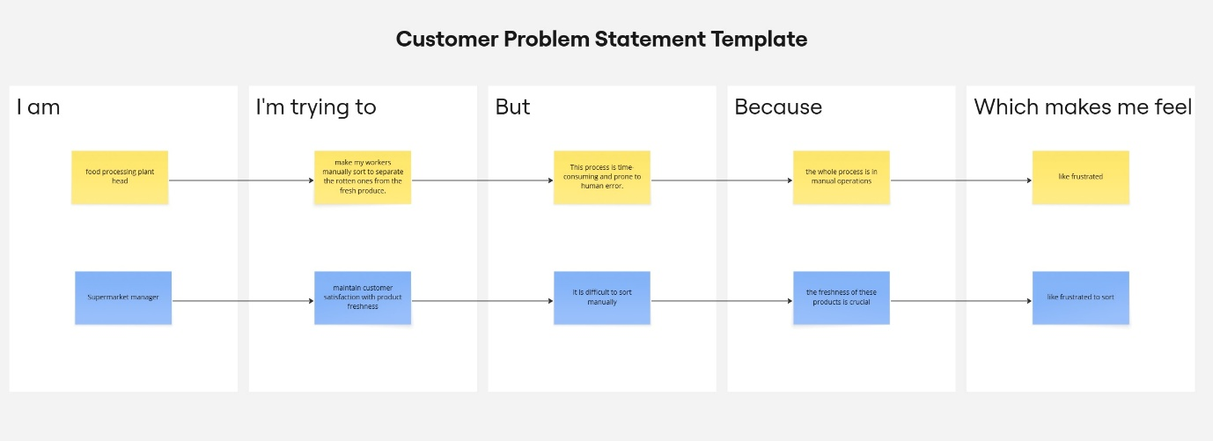

|  |  |  |  |  |  |
| --- | --- | --- | --- | --- | --- |
| **Problem Statement (PS)** | **I am (Customer)** | **I’m trying to** | **But** | **Because** | **Which makes me feel** |
| PS-1 | food processing plant head | make my workers manually sort to separate the rotten ones from the fresh produce. | this process is time-consuming and prone to human error. | the whole process is in manual operations | like frustrated |
| PS-2 | Supermarket manager | maintain customer satisfaction with product freshness | it is difficult to sort manually | the freshness of these products is crucial | like frustrated to sort |